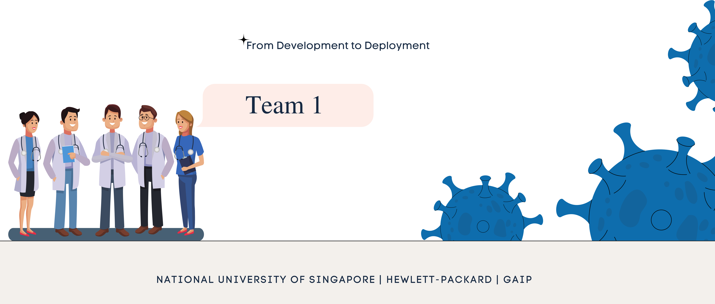Periodic learning in edge-fog-cloud computing, with a focus on diagnosing lung diseases with deep learning algorithms.

# Problem Statement

There are Multiple Challenges to deploy AI in Healthcare.

Privacy, Confidentiality & Transparency

Mitigation of bias

Data Storage

Accuracy and

Liability

a

.

b

.

c

.

d

.

NATIONAL UNIVERSITY OF SINGAPORE | HEWLETT-PACKARD | GAIP

Although the adoption rate of AI in the healthcare sector has been slower than in other industries, there has been an increase in interest from stakeholders.

Solution

Adoption of AI in Singapore's existing E-healthcare system:

This project proposes an E-healthcare solution based on edge fog cloud computing to enable periodic learning, which would indirectly contribute to the dynamic improvement of the accuracy of Deep Learning (DL) models.



rules, and system effectiveness and safety.

NATIONAL UNIVERSITY OF SINGAPORE | HEWLETT-PACKARD | GAIP

This project focuses on using deep learning models to diagnose lung diseases as an application of AI in healthcare.

We have also highlighted key insights regarding technology design and adoption, data security and privacy

# Understanding the Dataset

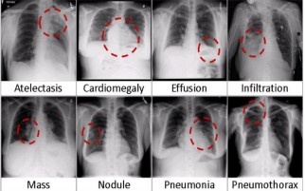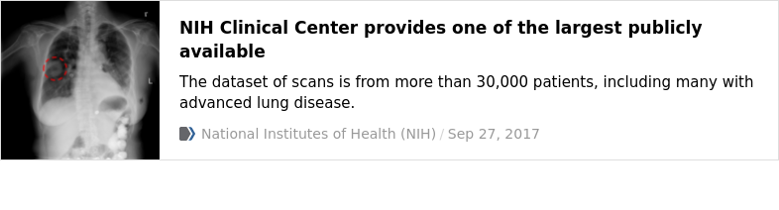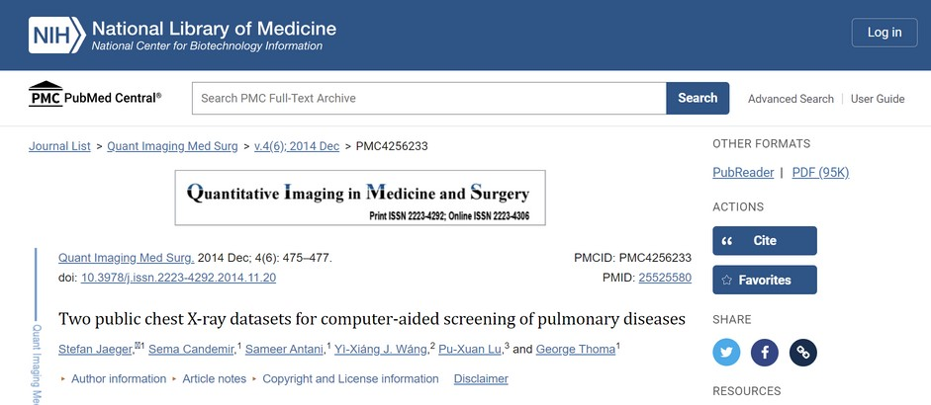

**X-ray Bone Shadow Supression**

Chest X-ray for the project

https://github.com/hmchuong/ML-BoneSuppression

Citations of all verified dataset used

NATIONAL UNIVERSITY OF SINGAPORE | HEWLETT-PACKARD | GAIP

# UNet - Image segmentation for extracting ROI

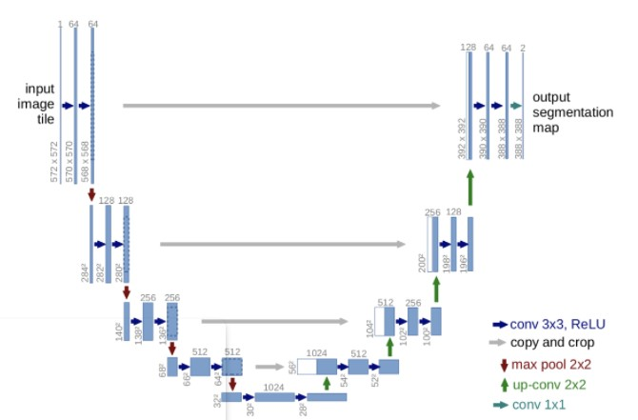**Why did we use UNet in our project?**

UNet is used in Bio-Medical Imaging for segmentation of the area of interest.

NATIONAL UNIVERSITY OF SINGAPORE | HEWLETT-PACKARD | GAIP

We wanted our model to focus only on the area of interest which are the lungs.

UNet helps us segment the lungs from the image leading into a higher accuracy for the model.

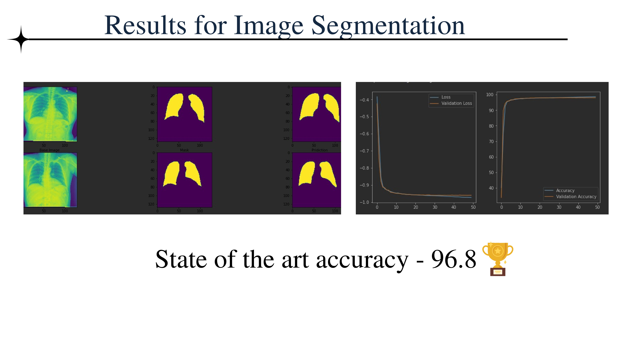

# Custom Filter

We introduce our custom Filter to mitigate any possible data loss cussed by UNet Segmentation

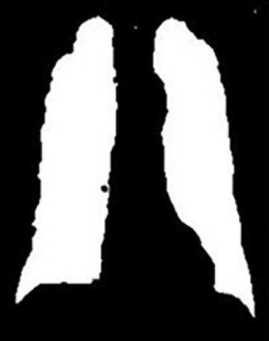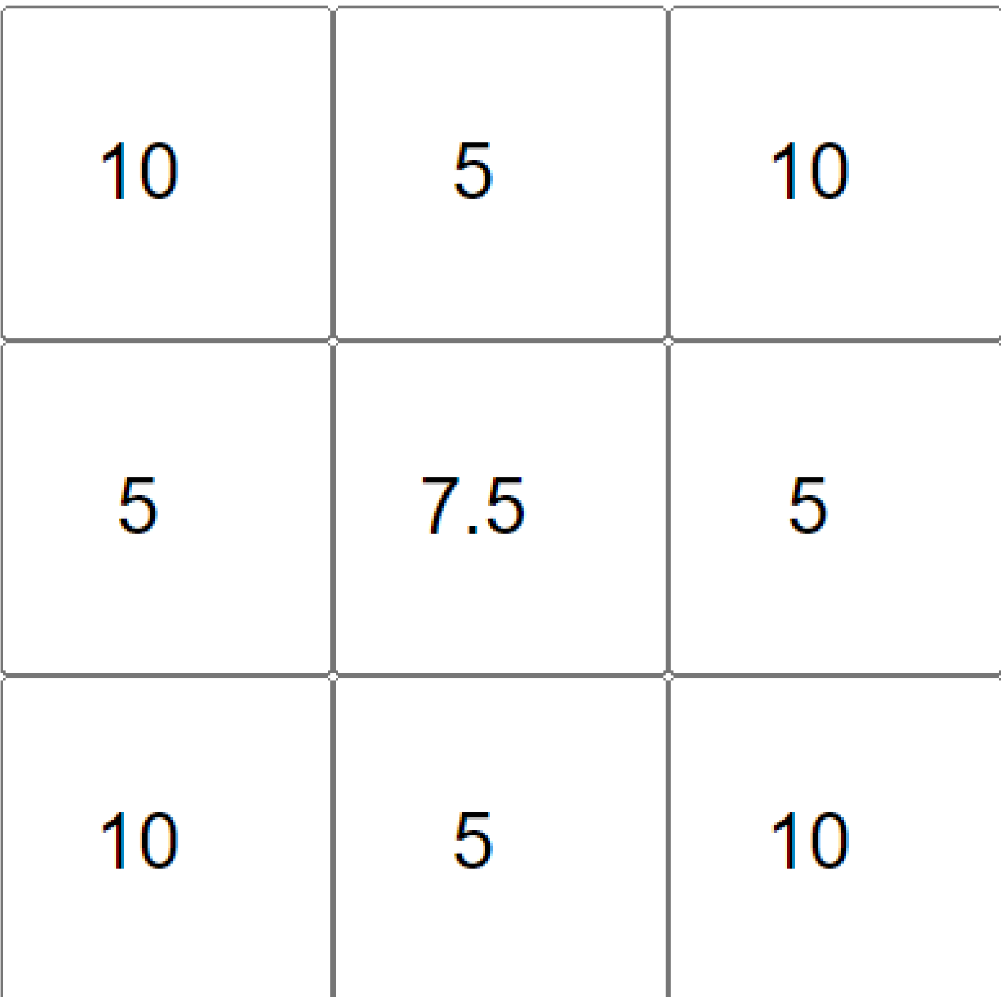

Input Mask Output Mask

Kernel

# Autoencoders - Bone Shadow Separation & Image quality Enhancement

Auto Encoders are Networks that work somewhat like GANs (Generative Adversarial

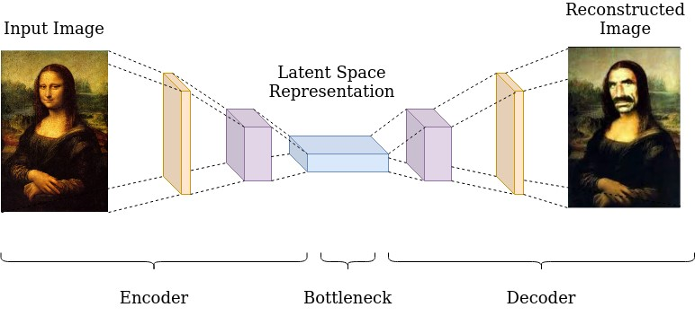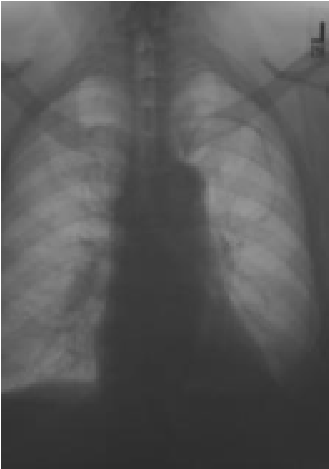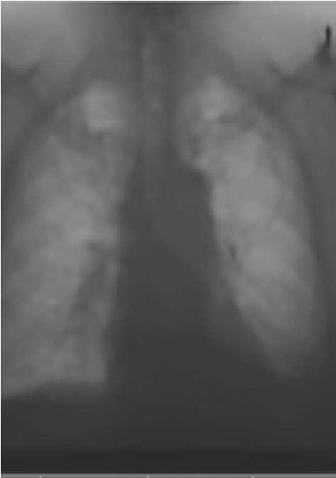

Networks) here there are two phases

1.Encoder

2.Decoder

# Results of Autoencoder

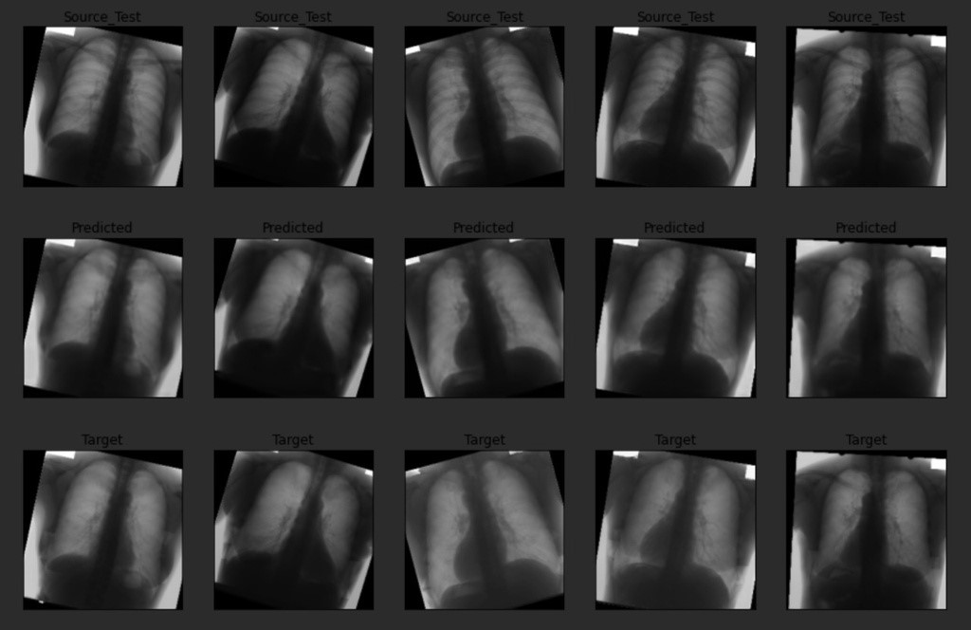

Got lowest Mean Square Error after comparing latest research paper MSE = 0.0010

## ChestNet- Diseases classification

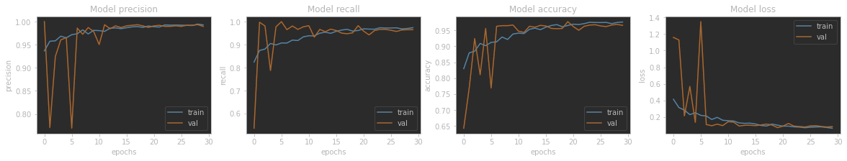

### Classified pneumonia with 96% accuracy

ChestNet- Diseases classificatio

n

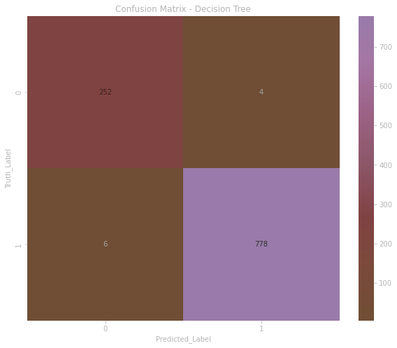

accuracy: 0.9830

precision: 0.9961

recall: 0.9809

val_loss: 0.0830

val_accuracy: 0.9692

val_precision: 0.9790

val_recall: 0.9790

lr: 2.2387e-04

## Pipe-Lining Boost

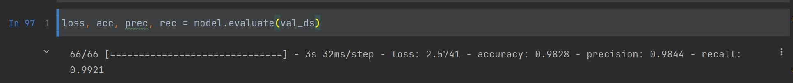

Pneumonia Classification boosted to 98.28%

accuracy

## Multi Diseases Classification

No Finding

Ededma

No Finding

Cardiomegaly

No Finding

Aclectis

No Finding

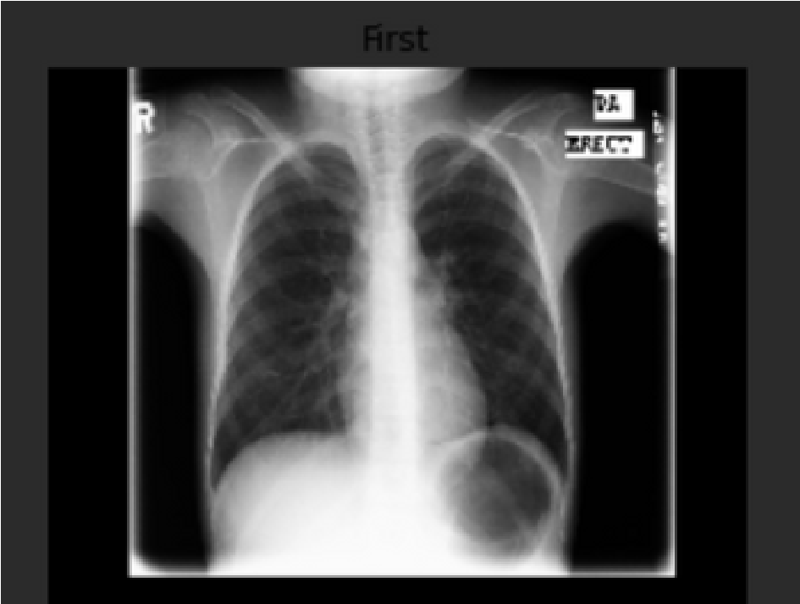

Confidence

Confidence

Confidence

Confidence

Results with High votes

V

o

t

e

1

V

o

t

e

4

V

o

t

e

2

V

o

t

e

3

Pneumonia

98

%

93

%

87

%

%

90

## Model Optimization

Quantization and Pruning

This technique brings improvements via model compression. In the future, framework support for this technique will provide latency improvements. We've compressed model to 1/3rd its initial size with minimal loss of accuracy.

|  |  |  |  |
| --- | --- | --- | --- |
| |  | | --- | | Model - 41 MB | | |  | | --- | | Model - 13 MB | |

INPUT OUTPUT

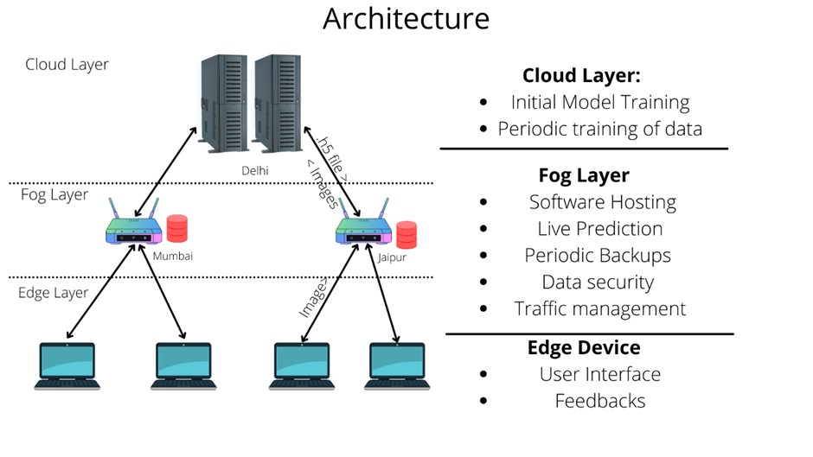

Web Interface

Upload Image

Feedback Mechanism

Results

C

o

r

r

e

c

t

N

o

t

S

u

r

e

Create a bucket of images

Periodic Learning

Wait for Feedback

with Reports

C

o

r

r

e

c

t

Wrong

Admin

Verifications with

report

## Security and Compliance

Restriction of data and application access ensures that only authorized users can access sensitive data. Encryption of data at rest and in transit makes it harder for attackers to decode any information even if they have access to it.

Frequent off-site data backups of the trained model are recommended while maintaining the stringent restrictions for data encryption, and access to ensure data backup security.

After the patient's images have been used for periodic learning, they will all be shredded.

To ensure high standards of privacy and confidentiality, none of the utilized images will be annotated with patients' personal information.

Data discovery and categorization play a key supporting role in implementing data usage rules by ensuring that sensitive data can be recognized and labeled to receive the appropriate level of protection.

# Business Scope

Microsoft Azure will host the Periodic Learning applications and databases.

**Depending on the computational utilization** of the deployed models, Azure services will be billed. We will sell fog devices to manage **software hosting, live prediction, periodic backups, data protection, and traffic management**.

Our business will provide for the configuration, installation, and maintenance of these fog machines. Once implemented, every authorized hospital staff with an edge device will be able to connect to the fog servers and upload their x-ray scans for evaluation.

**Cost of end-to-end deployment and updates**

Any **updates** to our models will be propagated from our cloud to the relevant fog servers, making them accessible to users.

Our primary expenditures will be for the **cloud server operation on Azure**, which will scale according to the website's demand.

## Model Architecture

**Unet - Image**

**segmentation for**

**extracting ROI**

Presentations are

communication tools

**Autoencoders**

**Image**

**-**

**quality**

**Enhancement**

Presentations are

communication tools

that can be uce.

**CNN - Image**

**classification**

Presentations are

communication tools

that can be used as

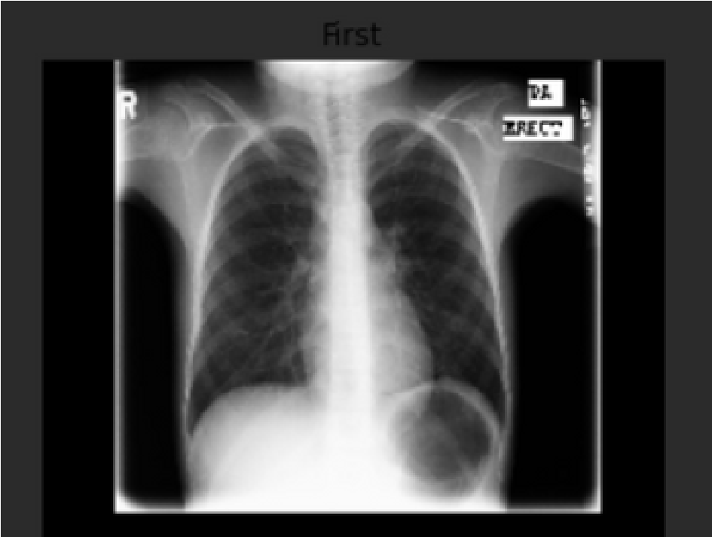

Classified Disease

Name

CURTIN HEALTHCARE SERVICES

Abstract-Overview

**Data Cleaning of NIH**

**Dataset - 1**

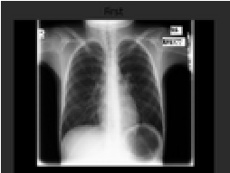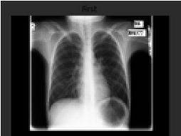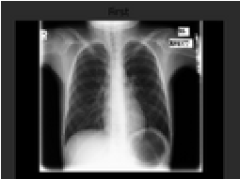

1

N

A

T

I

O

N

A

L

U

N

I

V

E

R

S

I

T

Y

O

F

S

I

N

G

A

P

O

R

E

|

H

E

W

L

E

T

T

-

P

A

C

K

A

R

D

|

G

A

I

P

**Data cleaning for Image**

**segmentation Dataset - 2**

**CNN Model evaluation**

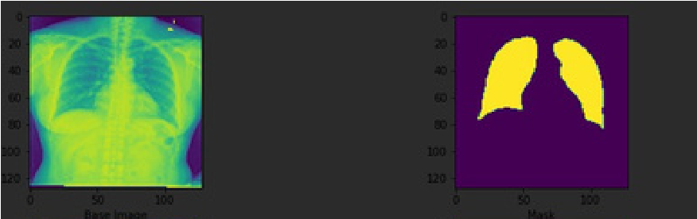

2

3

|  |  |  |  |
| --- | --- | --- | --- |
| **UNet Model Evaluation**    4 | |  | | --- | | **Data Cleaning for for**  5  **Bone Shadow Sepration -**  **Dataset -3** | | **Model Pipeline**    6 |

**Web Interface on Flask**

**Deployment of web app**

**on Azure**

**Edge-Fog-Cloud**

**Architecture Deployment**

7

8

9

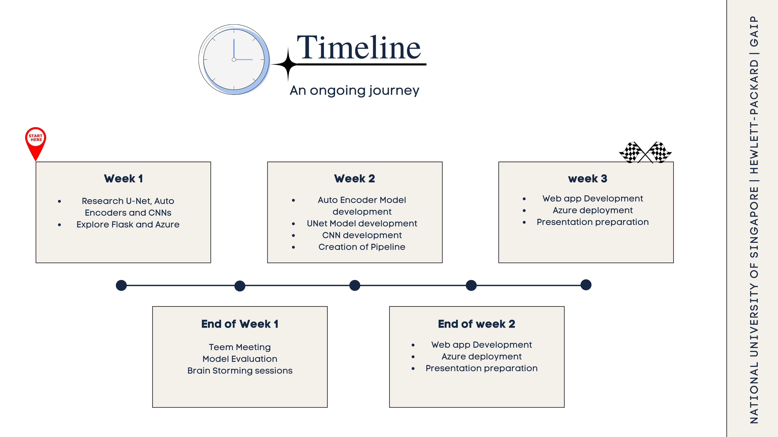

Objectives Achived

1. Cleaning the dataset for model training.
2. Use the Autoencoders model for biomedical image quality enhancement.

Analyse the results and prepare the research paper.

8

.

NATIONAL UNIVERSITY OF SINGAPORE | HEWLETT-PACKARD | GAIP

1. Use the image segmentation model (UNet) for extracting the Region Of Interest (ROI).
2. Architect state of an art model of CNN for image classification (ChestNet).
3. Creating a pipeline of UNet-Autoencoder-ChestNet model.
4. Design of a Flask-based web application for model deployment.
5. Deploy complete software on edge-cloud-fog architecture.

